ENGG-687
Ethics, Law, and the Engineering Profession
Assignment 2
Name | Ranjit Singh
UCID | 30301717
Assignment | Ethical Analysis

I have chosen to present this reflection assignment as a data visualization with supporting text. The Figure below is a chart I created. It plots how an architect’s ability to shape ethical outcomes falls, and the cost of changing course rises, across the software lifecycle. Below it, a grid maps my four course topics (APEGA Code of Ethics, Canadian law, value-based and uncertainty ethics, and IEEE 7000) onto each phase. The written sections that follow explain and reflect on what the visual shows.

The Architect's Window: Where Ethics Is Cheapest to Build In
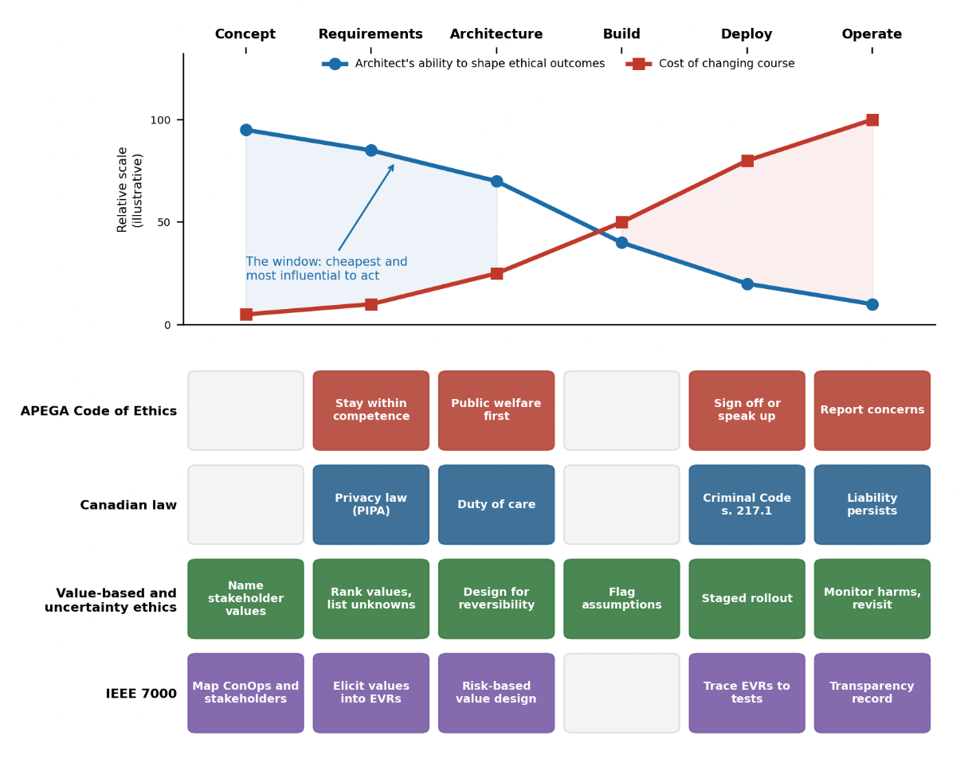
Top: How an architect's ability to shape ethical outcomes falls as the cost of changing course rises across the software lifecycle (conceptual illustration, not measured data).
Bottom: Where each of my four course topics applies in that lifecycle.
Topic | Where it appears | Key takeaway
APEGA Code of Ethics | Section 1, red lane in Fig. above | Public welfare outranks client/employer interests
Engineering laws in Canada | Section 2, blue lane | Duty is legal as well as professional
Value-based & uncertainty ethics | Section 3, green lane | Design for reversibility when outcomes are unknown
IEEE 7000 | Section 4, purple lane | Traceable method for turning values into requirements

The Idea
In software, the architect makes the choices that everyone else builds on. Figure above shows my argument: the ability to shape ethical outcomes is highest at Concept and Requirements, and the cost of changing course is highest at Deploy and Operate. Each of my four topics has a "home" in the lifecycle, and none of them works if I only think about ethics at the end.
1. APEGA Code of Ethics: public welfare comes first
The Code ranks the safety, health and welfare of the public above the interests of employers and clients [2]. For software, this is a design constraint, not a slogan. If I design a system so that switching off a risky feature needs a full redeploy, I have made the safe option expensive. That cost is mine to flag in the architecture review, not something the team should discover later. In Figure above, this is why the Code lights up at Architecture (design for welfare), Deploy (sign off or speak up) and Operate (report concerns).
2. Engineering laws in Canada: the duty is legal, not only professional
In Alberta, the Engineering and Geoscience Professions Act gives APEGA authority over practice and discipline [3]. Beyond professional discipline, s. 217.1 of the Criminal Code creates a legal duty for anyone who directs how work is done to take reasonable steps to prevent bodily harm [4]. An architect directs how a team builds, so this applies directly to safety-relevant software such as medical or industrial control systems. Privacy law adds another layer. Alberta's PIPA [5] means choices like data minimization and retention are compliance decisions made at Architecture, not paperwork added at the end. What surprised me most is that liability persists into Operate: the system keeps running long after the sprint ends.
3. Value-based and uncertainty ethics: designing for what we can't predict
Value-based ethics asks what stakeholders actually value, and then lets those values shape the design [6]. Uncertainty ethics asks how to act responsibly when consequences can't be predicted. Together they changed how I think about rules. Laws and codes lag behind technology, so for a new feature I may have no rule to follow. My response is to design for reversibility: staged rollouts, feature flags, monitoring, and a written list of assumptions I'm making. In Figure 1, this lane is the only one active in every phase, because uncertainty never goes away.
4. IEEE 7000: a method that makes ethics traceable
IEEE 7000-2021 gives a model process for addressing ethical concerns during system design [1]. It lets me map the system's concept of operations and stakeholders, elicit and prioritize values, turn them into Ethical Value Requirements (EVRs), and apply risk-based design with traceability and transparency [1], [6]. This matters because it turns "I have a bad feeling about this feature" into a documented requirement that can be tested and defended. One thing I disagree with, or at least question: IEEE 7000 is voluntary and process-based. It guarantees traceable reasoning, not good outcomes. A team could follow it perfectly and still rank values poorly. So, I see it as a tool that supports my judgment, not a replacement for it.

My responsibility as a future software architect
My next career step is software architect, and the topics above have made my responsibility concrete. "Software architect" is not a protected title, so unlike a licensed engineer, nothing forces accountability on me by default. I have to choose it. These are my commitments:
- I will pursue P.Eng. licensure with APEGA, so the Code and the Act bind me instead of being optional.
- I will add an "Ethical Value Requirements" section to my architecture decision records, following the IEEE 7000 approach, so values are written down at the Requirements stage.
- I will ask "what happens if we're wrong?" in every design review and require a rollback path before approving a risky design.
- If I'm overruled on a safety or privacy issue, I will put my concern in writing and escalate, consistent with the Code, instead of staying quiet.
These are commitments I'm choosing, and I haven't yet been tested on them. I expect the real test will be a deadline pressing against a design that doesn't feel right, and I want my habits to be set before that day comes.

References
[1] IEEE Standard Model Process for Addressing Ethical Concerns during System Design, IEEE Std 7000-2021, Sep. 2021. [Online]. Available: https://standards.ieee.org/ieee/7000/6781/
[2] Association of Professional Engineers and Geoscientists of Alberta (APEGA), “Code of Ethics.” Accessed: Oct. 18, 2026. [Online]. Available: https://www.apega.ca/members/legal-obligations/
[3] Engineering and Geoscience Professions Act, RSA 2000, c E-11. [Online]. Available: https://open.alberta.ca/publications/e11
[4] Criminal Code, RSC 1985, c C-46, s 217.1. [Online]. Available: https://laws-lois.justice.gc.ca/eng/acts/C-46/section-217.1.html
[5] Personal Information Protection Act, SA 2003, c P-6.5. [Online]. Available: https://kings-printer.alberta.ca/1266.cfm?page=P06P5.cfm&leg_type=Acts&isbncln=9780779856701
[6] S. Spiekermann, Value-Based Engineering: A Guide to Building Ethical Technology for Humanity. https://www.researchgate.net/publication/369078837_Value-Based_Engineering_A_Guide_to_Building_Ethical_Technology_for_Humanity

